One wire solution will not work!

While there may be several things that can cause this, if it is a problem of where regular solutions work but one wire solutions do not, you have a short somewhere, double check, and if you cannot find it, have a metal panel, and your jacks support jack plug detection, this may be your problem! The solution is so simple, but so hard to find sometimes, all you must do is bend this jack detect away from the contact as shown:

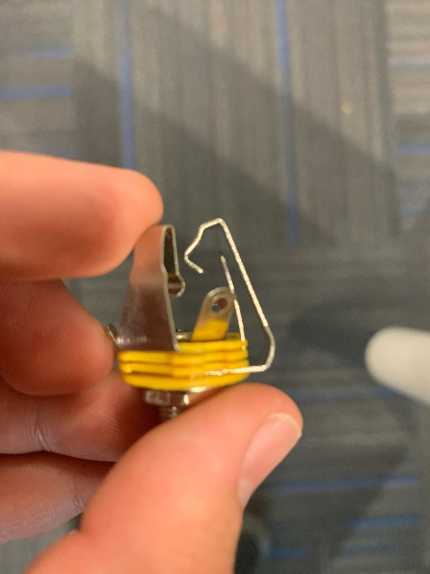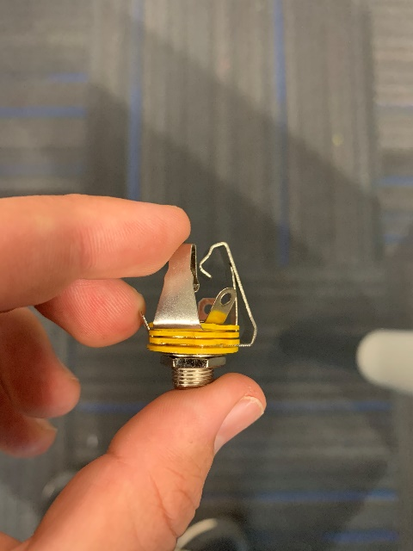**Before: After:**